Note: I tried using NMON on my machine a couple times, but it kept stopping, and wouldn’t say why it stopped (could see it running via ‘ps’, but after a while it would exit without a notice and without any output), for this I got images off the web of the NMON Visualizer that I’ll explain.

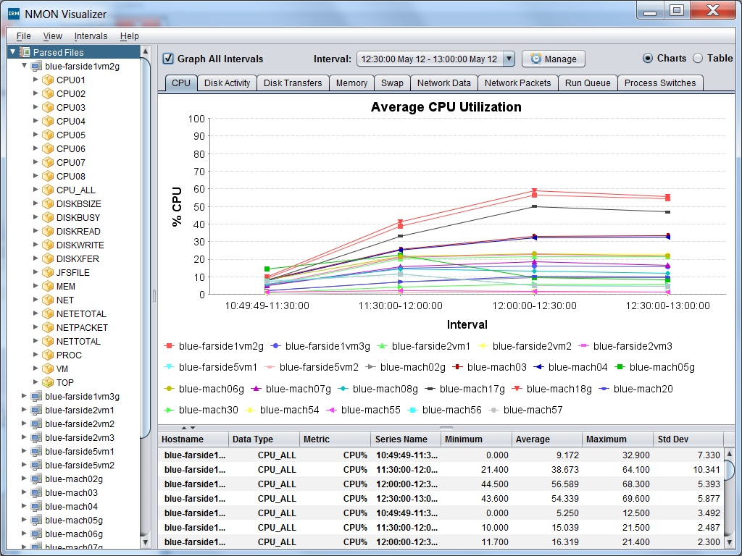

This is The Average % of the CPU that was being used over a time interval for a number of different machines analyzed. You can compare which machines had a higher load over that time (if they are virtual machines, you might want to give them more CPU’s since they might be running more computations in the future).

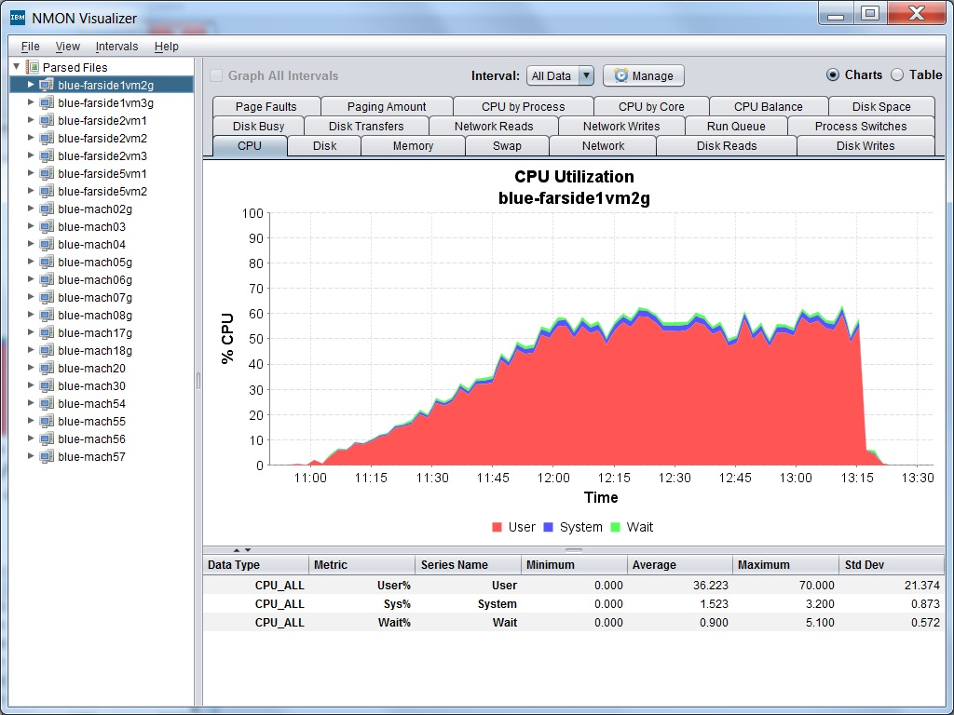

This screen shows the %CPU used for a machine over a period of 4 and a half hours. This can be useful to see how much more a CPU can be used over a period of time (Since the goal is to always have the CPU have tasks to do!)

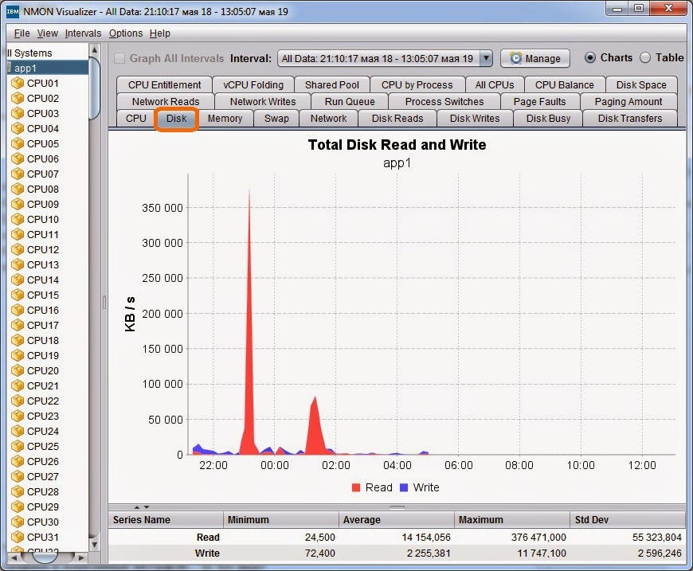

This is the Speed of The Read/Write to a disk over a period of 14 Hours. This can be useful to see how much was written/read to a device, and can be used to see what the maximum read/write is for a device while performing typical tasks over a period of time (to then be able to estimate how long a large future read/write would take)